EXPERIMENT-05 DHILIPAN M
21/07/2026 192411038

MISSIONARIES AND CANNIBALS’ PROBLEM USING BREADTH-FIRST SEARCH (BFS) ALGORITHM.
AIM:
To write a Python program to solve the Missionaries and Cannibals Problem using the Breadth-First Search (BFS) algorithm.
ALGORITHM:
Step 1: Represent the initial state with all missionaries and cannibals on the left river bank.
Step 2: Represent the goal state with all missionaries and cannibals on the right river bank.
Step 3: Generate all valid successor states by moving one or two people across the river.
Step 4: Ensure that missionaries are never outnumbered by cannibals on either bank unless there are no missionaries present.
Step 5: Apply Breadth-First Search (BFS) to explore all valid states.
Step 6: Display the sequence of states from the initial state to the goal state if a solution exists; otherwise, display "No Solution Found."
PROGRAM:
from collections import deque
def valid(m, c):
return (m == 0 or m >= c) and (3 - m == 0 or 3 - m >= 3 - c)
moves = [(2,0), (0,2), (1,1), (1,0), (0,1)]
start = (3, 3, 0)
goal = (0, 0, 1)
queue = deque([(start, [start])])
visited = set()
while queue:
(m, c, b), path = queue.popleft()
if (m, c, b) == goal:
print("Solution Found")
for state in path:
print(state)
break
if (m, c, b) in visited:
continue
visited.add((m, c, b))
for dm, dc in moves:
if b == 0:
nm, nc, nb = m - dm, c - dc, 1
else:
nm, nc, nb = m + dm, c + dc, 0
if 0 <= nm <= 3 and 0 <= nc <= 3 and valid(nm, nc):
if (nm, nc, nb) not in visited:
queue.append(((nm, nc, nb), path + [(nm, nc, nb)]))
else:
print("No Solution Found")

OUTPUT:

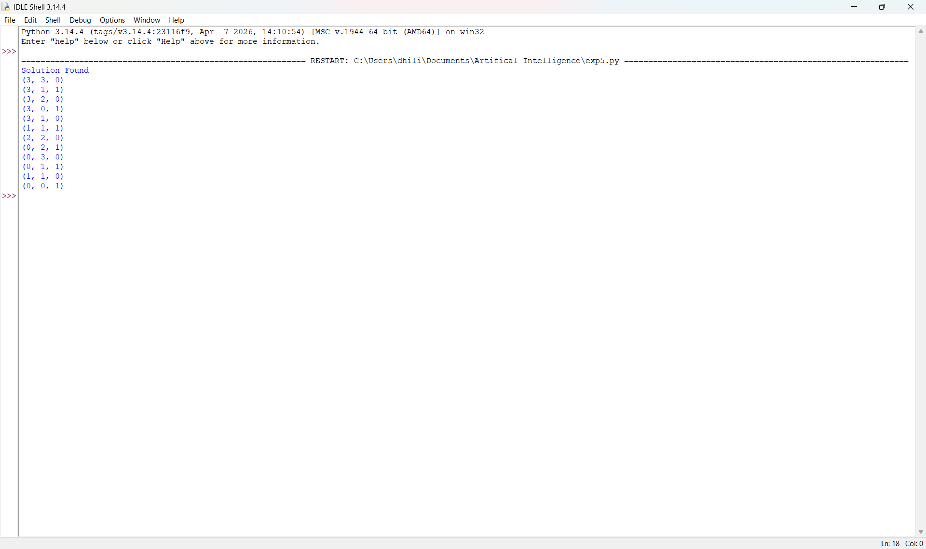

RESULT:
Thus, the Python program to solve the Missionaries and Cannibals Problem using the Breadth-First Search (BFS) algorithm was implemented successfully and the required output was obtained.

